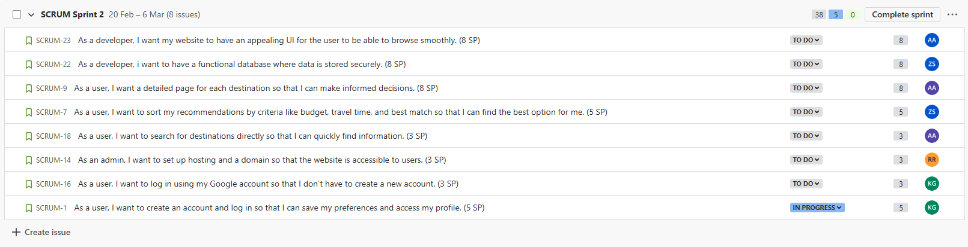

***The user stories (in full display):***

1. **As a user, I want to create an account and log in so that I can save my preferences and access my profile. (5 SP) assigned to Khalil.**
2. **As a user, I want to log in using my Google account so that I don’t have to create a new account. (3 SP) assigned to Khalil.**
3. **As an admin, I want to set up hosting and a domain so that the website is accessible to users. (3 SP) assigned to Rafic.**
4. **As a user, I want to search for destinations directly so that I can quickly find information. (3 SP) assigned to Anthony.**
5. **As a user, I want to sort my recommendations by criteria like budget, travel time, and best match so that I can find the best option for me. (5 SP) assigned to Zaed.**
6. **As a user, I want a detailed page for each destination so that I can make informed decisions. (8 SP) assigned to Anthony.**
7. **As a developer, I want to have a functional database where data is stored securely. (8 SP) assigned to Zaed.**
8. **As a developer, I want my website to have an appealing UI for the user to be able to browse smoothly. (8 SP) assigned to Anas.**

***Tasks:***

**During Sprint 2, the team members are required to maintain a level of communication, continue acquiring necessary knowledge to ensure they have the tools needed to work, and attend the daily SCRUM meetings. For Sprint 2, the team will still collaborate closely, building upon the website's foundation, and will gain more independence and freedom in their work. However, clear communication and meeting goals at the end of each sprint will remain essential. I, Anas Abdul Aziz, as the SCRUM Master, will ensure that my team follows the Agile methodology and SCRUM framework during this sprint.**

**In Sprint 2, the team will work on implementing secure account creation with both standard and Google login options, setting up hosting and a domain to ensure accessibility, and developing features that allow users to search for destinations and view detailed pages and refined recommendations, while developers focus on creating a secure database and an appealing, user-friendly interface.**